VERIFICA CLASSE 2^_NUMERO E CALCOLO  
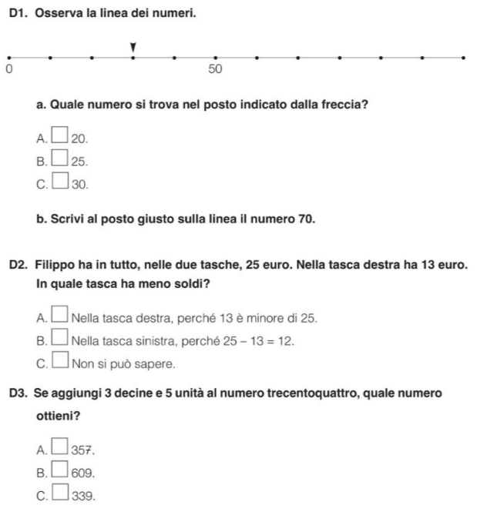

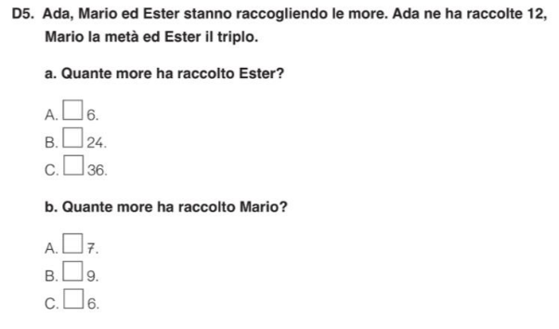

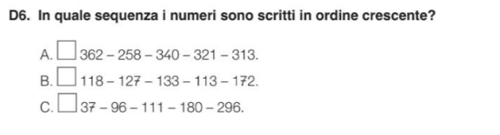

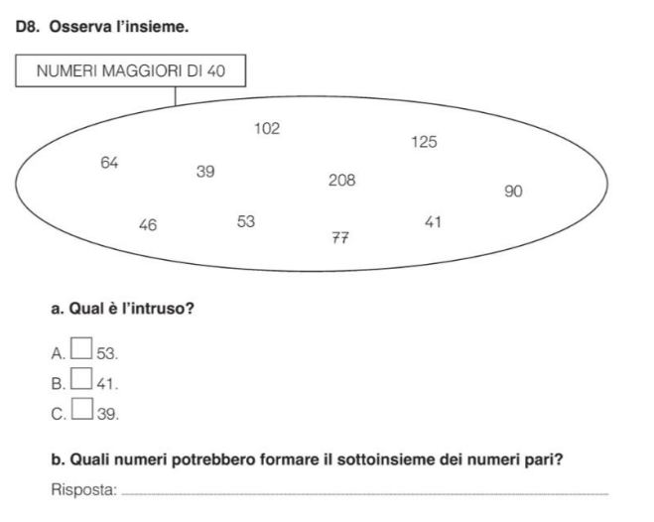

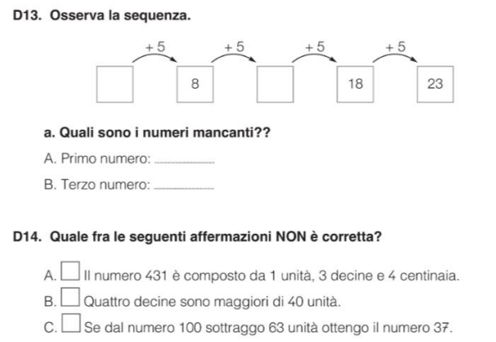

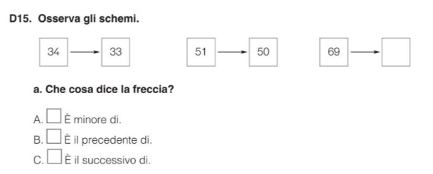

ESEGUI IN RIGA

|  |  |  |  |
| --- | --- | --- | --- |
| 17 + 6 = ……………  48 + 8 = ……………  87 + 11 = ………….  56 + 20 = ………….  25 + 25 = …………..  46 + 12 =…………… | 35 – 7 = ………….  71 – 5 = ………….  40 – 12 = …………  100 – 40 = …………  45 – 11 = …………..  50 – 25 = ……….. | 4 X 5 = ………….  6 X 3 = …………  6 X 8 = …………  2 X 7 = ………….  3 X 8 = …………..  2 x 0 = …………… | 18 : 2 = …………  25 : 5 = ………….  21 : 3 = …………..  24 : 6 = …………….  42 : 7 = …………….  10 : 2 = …………… |

ESEGUI IN COLONNA

|  |  |  |
| --- | --- | --- |
| 67 + 19 = __________ | 54 – 28 = ____________ | 28 x 3 = ____________ |
| |  |  |  | | --- | --- | --- | | da | u |  | |  |  | + | |  |  | = | |  |  |  | | |  |  |  | | --- | --- | --- | | da | u |  | |  |  | - | |  |  | = | |  |  |  | | |  |  |  | | --- | --- | --- | | da | u |  | |  |  | x | |  |  | = | |  |  |  | |